Australian Service Excellence Awards
2022 Organisation Nomination Questionnaire

Organisation Name:

Award Category:

Judging Criteria
There are five sections in this document that provide you the opportunity to explain why your organisation, team, project or contact centre should be considered for the relevant award category. Four of these sections reflect the below service perspectives, that underpin the International Customer Service Standard (ICSS: 2020-2025). Under each section we have provided some guidance on what you may like to include.

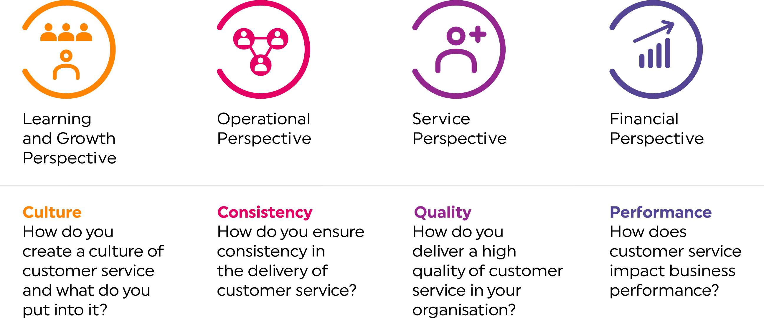

- Overview of project, team, organisation or contact centre
Please provide an explanation of your organisation, team, project or contact centre and why you feel that they should be considered for an award (approx 250 words).

- Learning and growth perspective
How has your organisation, team, project or contact centre created a culture of customer service?
In this section you may also wish to outline how the skills and talents of staff are improved to deliver superior customer service, for example learning and development programs, reward and recognition initiatives, and any specific recruitment methodology you follow. In addition, you may wish to highlight what and how technology is leveraged to create positive customer experiences (approx 250 words).

- Operational perspective
What ways of working are implemented within your organisation, team, project or contact centre to ensure that a consistent level of superior customer service is delivered? What mechanisms and systems are in place to ensure a better level of customer service? How is the quality of customer service measured? If applicable, how have you ensured after sales service is delivered? (approx 250 words)

4. Service perspective
In this section you may wish to outline how your organisation, team, project or contact centre collaborates with customers, suppliers and partners to deliver a better quality of product or service. If applicable, how have you used market trends and industry best practice to deliver better customer service? You may like to include how long-term relationships with customers have been built, how complaints are handled, how customer insights are collected, and how these insights are used for continuous improvement purposes (approx 250 words).

5. Finance and governance perspective
How has your organisation, team, project or contact centre created growth in revenue, cost efficiencies and profit for the organisation in delivering superior customer service? If applicable, you may wish to highlight how corporate social responsibility has played a role in this (approx 250 words).

